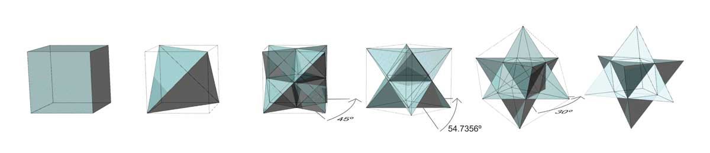
From Cube to Merkaba (double tetrahedron) - a beautiful geometric metaphor of dimensional evolution.

The following is intended for free dissemination, I have included copyright info simply to protect myself, not to stop contextual redistribution. Of copyrighted images of others (listed at the end of this document) their permissions have been granted for free redistribution in the context that I have presented.

Great Pyramid as Ark and Elevating Consciousness Teaching Tool

The Great Pyramid of Giza has captured the imagination of many minds throughout history, and recently I too have fallen victim!
In the following I mean to explain why I have come to the conclusion that the Great Pyramid is part of a mechanism designed to safeguard life on this planet, whilst also being a method to force an evolution of consciousness in the human animal.

This evolution will require the exposure of a secret shaft in the Great pyramid, similar to the ‘air shafts’ discovered by Wayman Dixon in the ‘Queen’s chamber’ in 1872. At approximately 69 m (226.4 feet) from the entrance, down the Descending passage, according to my theory, intuitions and diagrams, may be found a small panel in the ceiling. I expect this panel to be of a similar size to that in the Queen’s Chamber (IE about 200 mm square, or 8 inches.) Dowsing rods may help hone in on the exact position of the panel, and/or there might be some differentiation, the symbol of Aquarius and/or the Egyptian hieroglyph for water might mark its position.

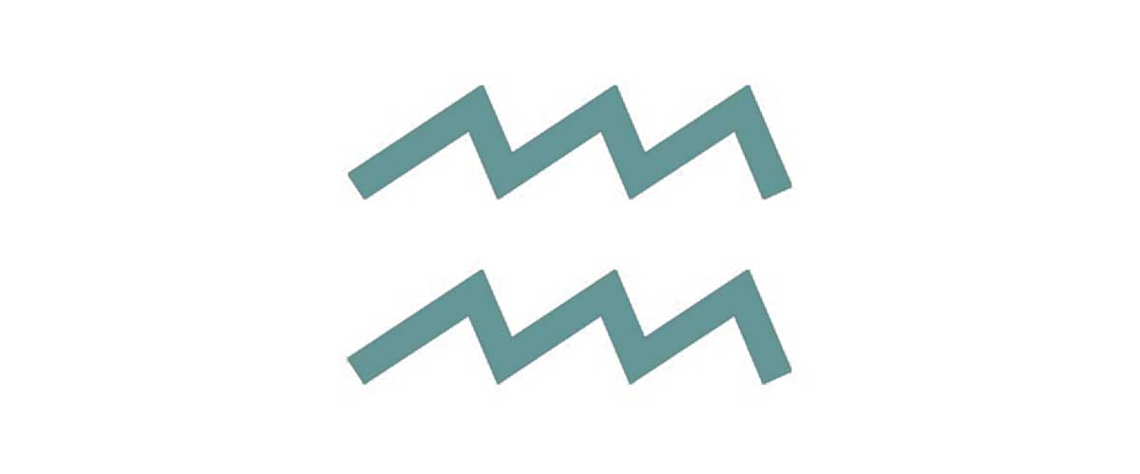
The braking of this panel will be akin to turning the Pyramid back on, but this should be done when no one is further down the passage or in the well or Subterranean Chamber as I expect water to flood these areas. The breaker of the panel should be ready to vacate at least to the height of the junction with the Ascending passage, which is also the height of the Grotto, but exiting entirely would be safest.

There could be other actions to be taken, but the above instruction will set in motion events which will cleanse the energy centres of this planet and enable a higher integration of human consciousness.

Once these waters are allowed to flow, my expectation is that a chamber under the Great Pyramid but only accessible externally currently, known as the ‘Tomb of Osiris’ (video of Erich Von Daniken discussing it) will be drained of its water. In the basement of this chamber is a ‘sarcophagus’ (much like the Coffer in the King’s Chamber, but blue Granite rather than red) submerged in water and kept clear of the stone floor by way of joists at either end. Once the water is drained and the sarcophagus is connected to the stone floor (which is probably limestone) the secure ‘backup’ free energy device, will be connected, and the dynamics of power of this planet will evolve.

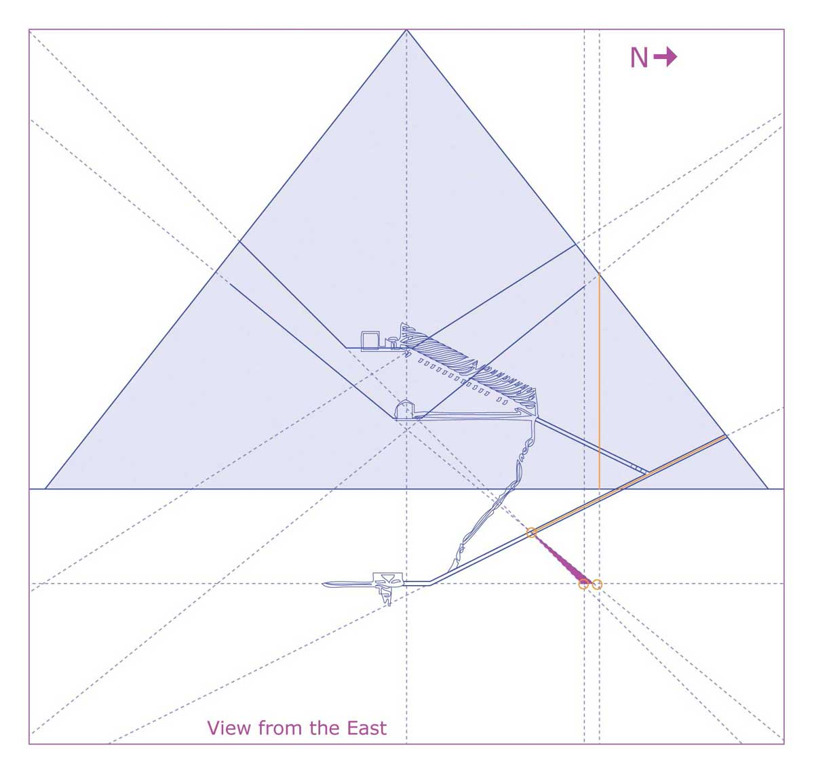
© Ashleigh Watt. 2017 www.tescera.com

Contents

Overview 3
A new diagram of the Great Pyramid 5
The beginning of my rabbit hole 16
Bible Passages 17
Anti-gravity 18
The Precession Connection 18
The Architecture of Deception 19
Crabwood 20
Serendipity 21
Personal Suppression 21
Secrecy 21
Younger Dryas 22
Ark of the Covenant 22
Reptilians 24
The Middle-East 25
Noah’s Ark 25
Eschatology 26
The Blue Sarcophagus 26
Aquarius 28
Movies and Books as mythology 28
Conclusion 29
References 31
Influential Thinkers / Intended Recipients 31
Images Used with Kind Permissions 31

Overview

Long ago, before history, a high civilization existed on this planet, evidence of this is heaping up, but the establishment persistently denies it. Exactly who these people were is hard to lock-down, what is important however, is that after a global cataclysm all but wiped their existence from the Earth, the survivors sort to safeguard humanity. They built the Pyramid complex, installed, what we might call a free energy device in the great Pyramid, and collected genetic material, what we call mummification.

So amid the cooling conditions of the Younger Dryas around 10,900 BC, The Pyramid and its energy source created a veritable ‘Garden of Eden’ for immature humanity. And the storage of genetic material (Noah’s Ark) meant that all forms of life might survive the flooding of around 9,700 BC

But it wasn’t as simple as that! Immature humanity was much like Terrence McKenna’s ‘Stoned Apes,’ blissful ignorant, but ‘in touch.’ So the Great Pyramid involves a greater challenge, that of evolving consciousness. Like an alarm clock, in 2500 BC the alignments in the king’s Chamber point to Orion in the South and to Draco in the North. It is in this time, in the Age of Aries (God of War), that the ‘angels’ of Orion and the ‘demons’ of Draco, work together to begin the suppression of Humanity - otherwise known as ‘History.’

History is rife with examples of suppression and oppression, and anyone with an American dollar bill may see that symbolized by the pyramid, and its implied hierarchies.



It may be hard for some people to understand how suppression can be a tool for spiritual growth and evolution, but those who have suffered trials can find through incite, that those trials helped them to grow. Thereby, they become thankful of their difficulties, as I have done. Most obviously my trials have aided my views put forth here.

Having planned for suppression the pyramid builders also planned for our liberation. All this time, through all our hardships a backup free energy device has been waiting to be discovered and to be freed from the waters that act like an insulator around it.

I recently heard David Icke describing suppression metaphorically, as holding a ball (presumably air-filled like a football) down in a tank of water. The point being that its natural state was to float on the surface, so it wanted to return. Missing from his metaphor was the fact that when the ball is held down and eventually released, it shoots out of the water far beyond its original state. It is that ‘shooting beyond’ that we are geared for, that the Pyramid program has readied in us, and if I am right the breaking of a small panel will set in motion unstoppable events that will shoot us far beyond!

A new diagram of the Great Pyramid

I have come to consider the Pyramid a teaching-tool, Crop circles too have much to teach us. In retrospect studying them only vaguely as I have done, has opened my thinking and encouraged my intuition.

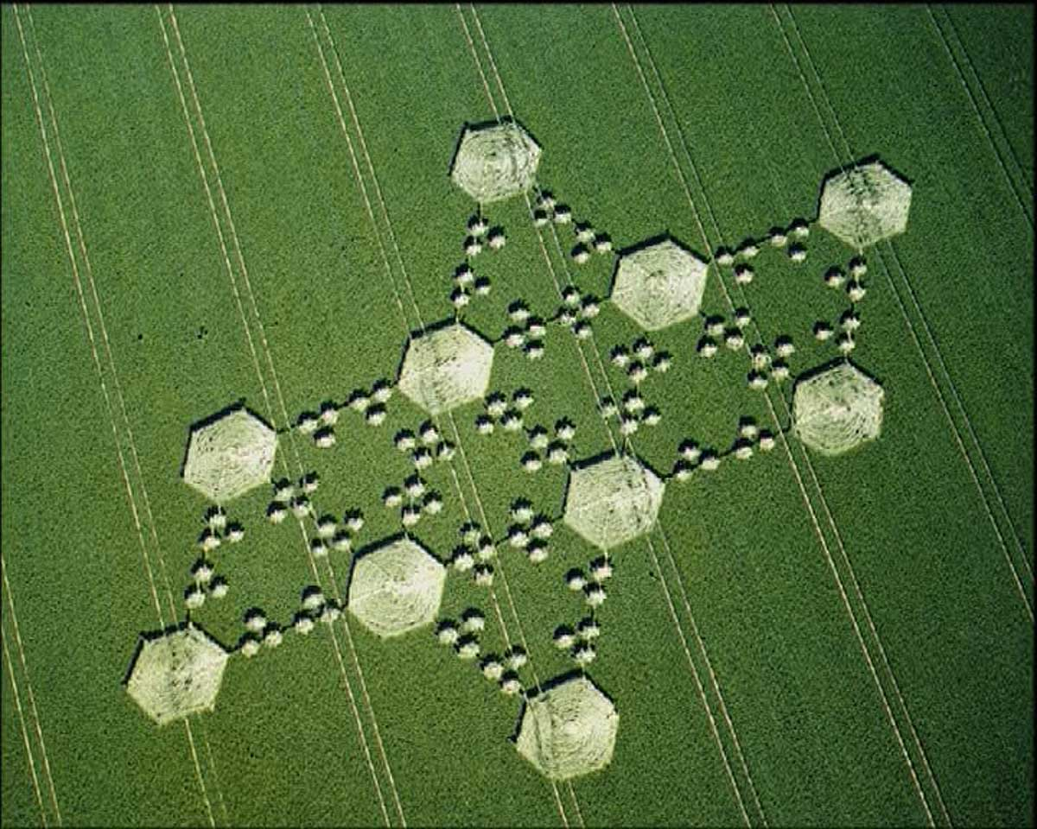
Copyright: Colin Andrews 1999, http://www.ColinAndrews.net/

This appeared in West Overton, Wiltshire England in 1999, in essence it depicts an octahedron made up of 8 equilateral triangles, if one were to fold along the vertices. This brought to mind the Great Pyramid but with a mirrored version under its base.
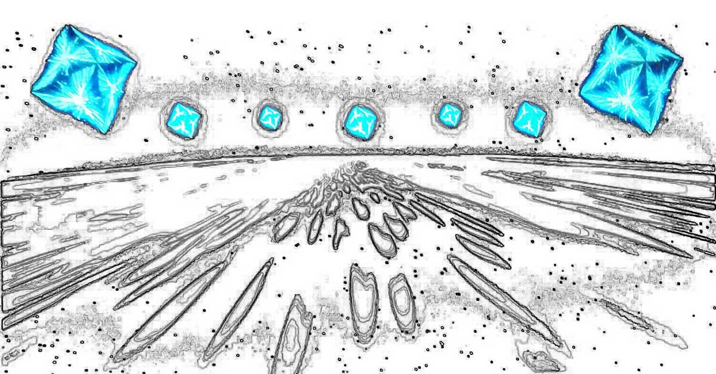
© Ashleigh Watt. 2017 www.tescera.com
Scene from 2001: A Space Odyssey - floating octahedrons.

It was this suggestion of under the pyramid that made me think to project the lines of the ‘air shafts’ down as well as up. What I found was that the downward projections of both South pointing shafts intersected the descending chamber at the same point. And that, from that point to the entrance appeared to equate to the vertical distance from the base of the Pyramid to the projected exit of the Queen’s Chamber shafts. Also when that line and a vertical line from the end of that shaft were projected straight down, they came very close to intersecting the Southern downward projections in alignment with the Subterranean passage. Hence these alignments seem to suggest a secret shaft running down at an angle from a point 69m along the descending chamber, possibly it funnels out taking up both projections.
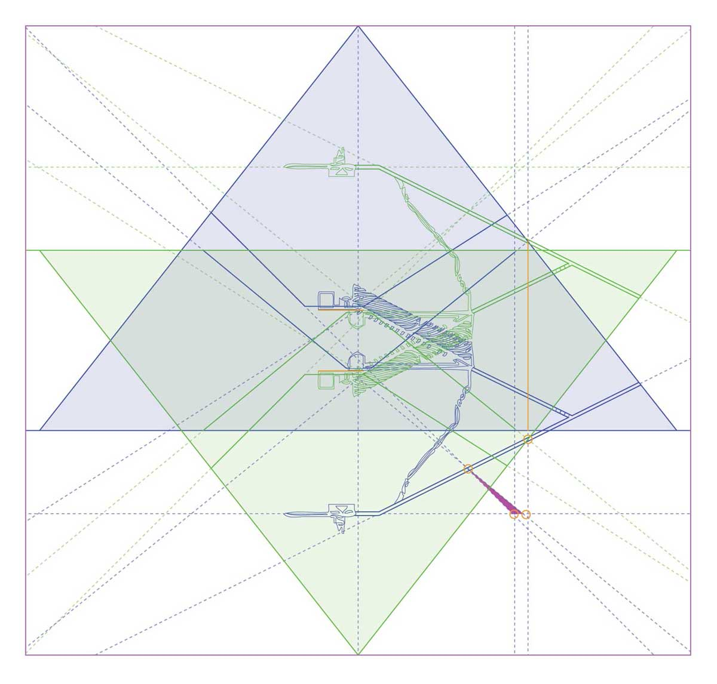
© Ashleigh Watt. 2017 www.tescera.com

Then I thought I would add a mirrored version, and after playing with its position I found that positioning the base of the inverted pyramid at the ends of the Queen’s Chamber shafts (much like resting the image on negative supports - which is appropriate for an inverted image :) then the floors of both sets of King and Queen chambers aligned, and the Descending Passage aligned with the projected exit of the inverted Northern Queen’s shaft.

The curious nature of the Queen’s Chamber shafts has caused much debate, if I am right their curious details designate the intended geometric positioning as above, and point downward with more information than that of the King’s Chamber. Knowing well the hermetic adage “as a above, so below” which is normal interpreted less literally, one imagines this idea should been have been imagined earlier.
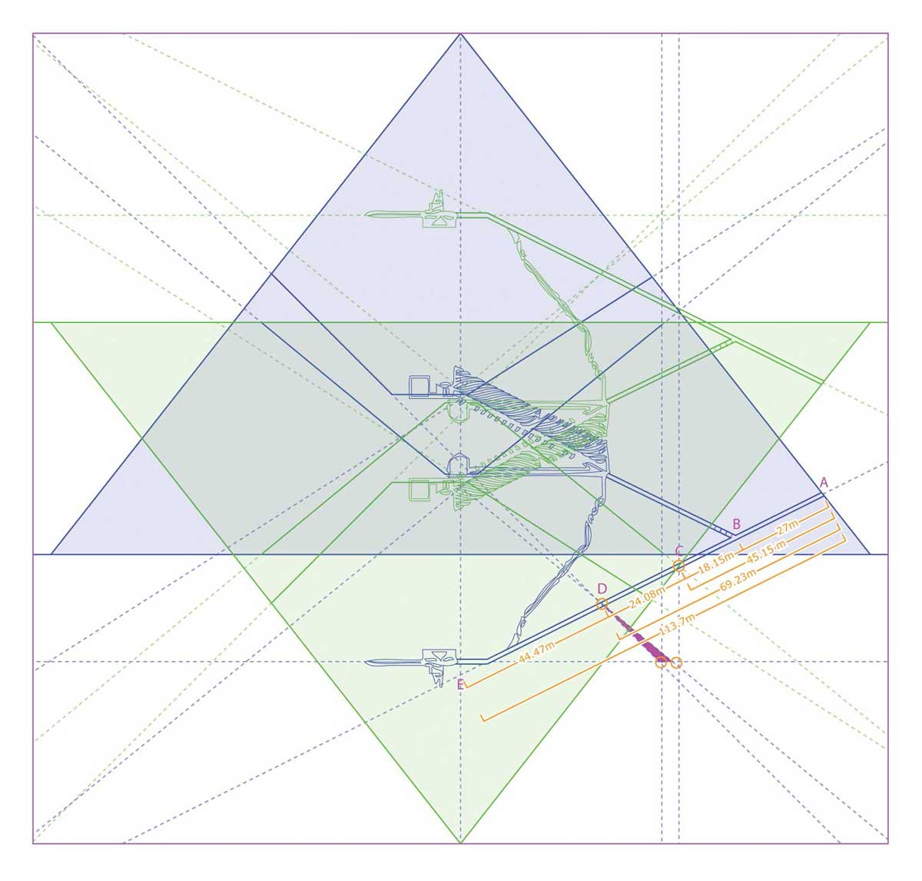
© Ashleigh Watt. 2017 www.tescera.com

So then I had to calculate the dimension/position of these points along the Descending passage, including its projected intersection with the central axis, and was impressed but not surprised to find progressive Phi (ɸ = 1.618) relationships.

• From the Entrance (A) to the start of the junction with the Ascending Passage (B) = 27m approx
• From the junction with the Ascending Passage (B) to the intersection with the inverted projection of the Northern Queen’s shaft exit (C) = 18.15m approx
• From the intersection with the inverted projection of the Northern Queen’s shaft exit (C) to the intersection with both downward projections from each Southern shafts (D) = 24.08m approx
• From the intersection with both downward projections from each Southern shafts (D) to the intersection of the projected Descending Passage with the central axis (E) = 44.47m approx

AB x ɸ = AC
AC x ɸ = AD
AD x ɸ = AE

So point D not only aligns with both Southern shafts but also is part of an elaborate golden mean (Phi) relationship. At point C there might also be something worth checking out, but my impression is that it simply forms part of this diagrammatic puzzle.
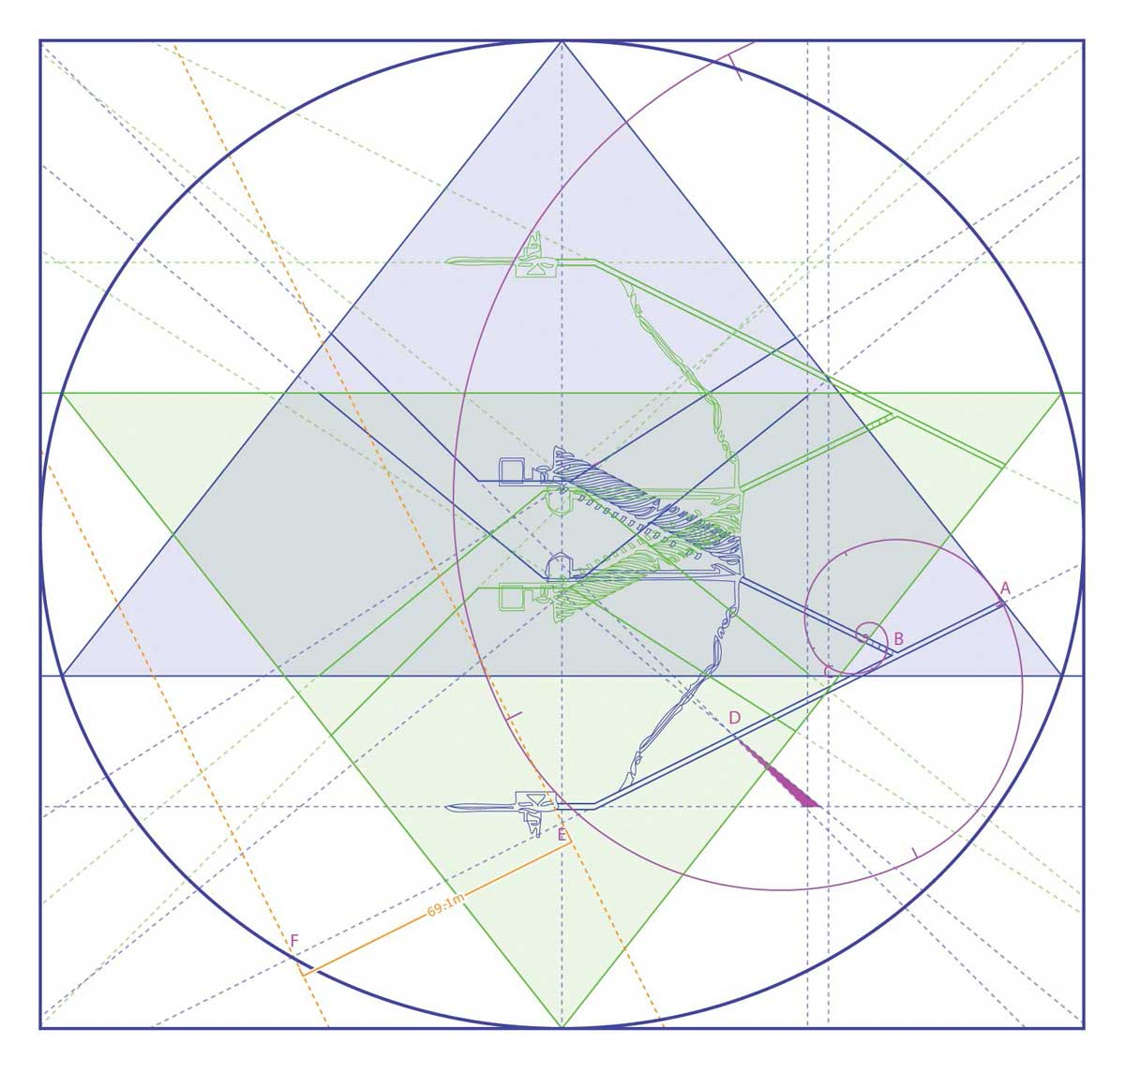
© Ashleigh Watt. 2017 www.tescera.com

A Phi relationship makes one want to project a Fibonacci spiral over the diagram, a few positions are possible but the above seems to best articulate the dimensions and it sits neatly in the corner of the Pyramid. Also the centre of the spiral rests just above the 3 plugging stones in the Ascending Passage.

The 6 points of the ‘Star of David’ can map an ellipse, the result is wider at the horizontal than the vertical, just as the Earth is an oblate sphere.

Having added the ellipse I noticed a further Phi relationship; from the intersection of the projected Descending Passage with the central axis (E) to the intersection of the projected Descending Passage with perimeter ellipse (F) = 69.1 m approx

AE x ɸ = AF
EF = AD

It seems the longer I look, the more relationships I find!

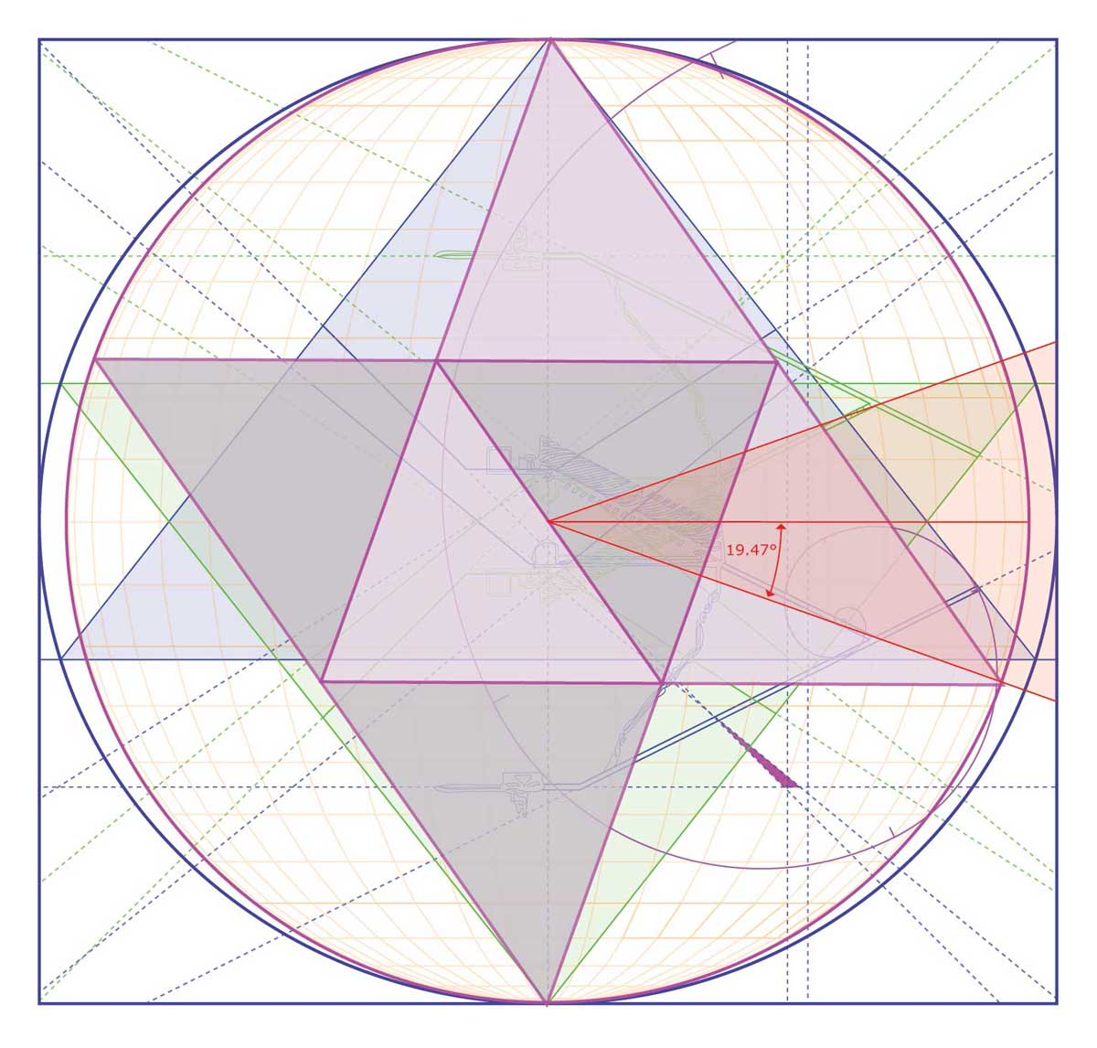
© Ashleigh Watt. 2017 www.tescera.com

The height of the ellipse to its width is 1:1.0571

If we draw lines from the centre of the diagram, bisecting the plug stones, they approximate 19.47° from the equator or horizontal. This angle is implicit in the hyper-dimensional torsion field model as described by Richard Hoagland. The double tetrahedron or Merkaba represents this, it is the higher dimensional shape born of the cube, which represents our 3 dimensions and matter. Transmutation is more a matter of orientation or perspective, than anything else.
© Ashleigh Watt. 2017 www.tescera.com

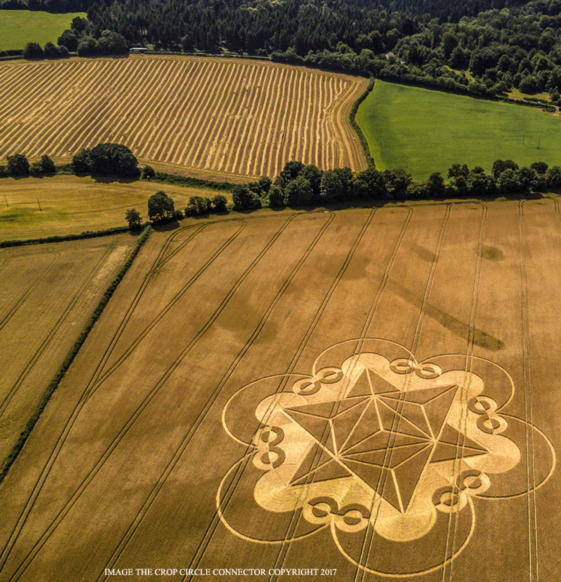
© www.cropcircleconnector.com / M.Williams!
Cley Hill, Nr Warminster, Wiltshire. Reported 18th July. 2017

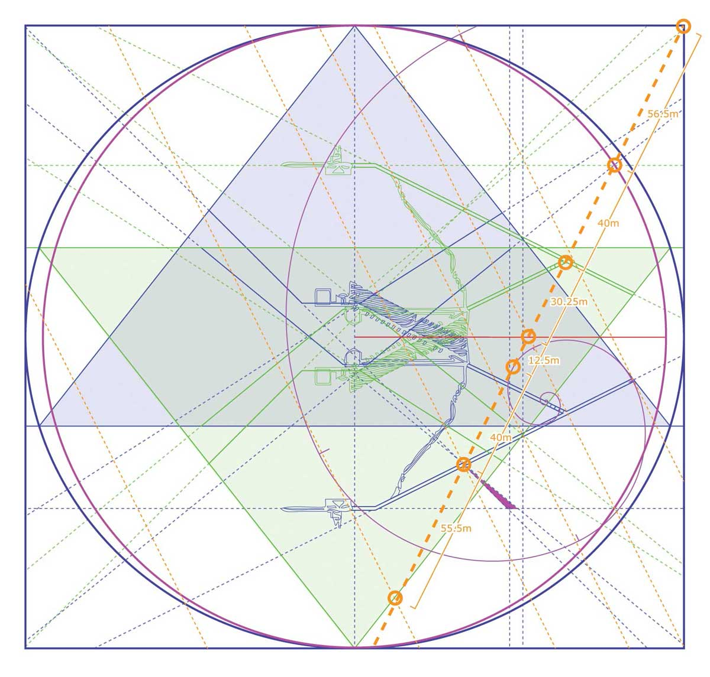
© Ashleigh Watt. 2017 www.tescera.com

Then I realised that a line perpendicular to the inverted Descending passage at the junction with the inverted Ascending chamber passes straight through point D, this secret panel position. But also it sat neatly over the Fibonacci spiral, and 4 other intersections marked in the above diagram. The dimensions between each show a mirroring outside of the centre 2, but otherwise no obvious ratio relationships.

I included the corners of the squared eclipse as an intersection point, in the above. Of note is that each of the ‘air shafts’, except that of the Northern King’s Chamber (pointing to Draco) intersects (either projecting upwards or downwards) the corners of the perimeter rectangle in both actual and inverted orientations.

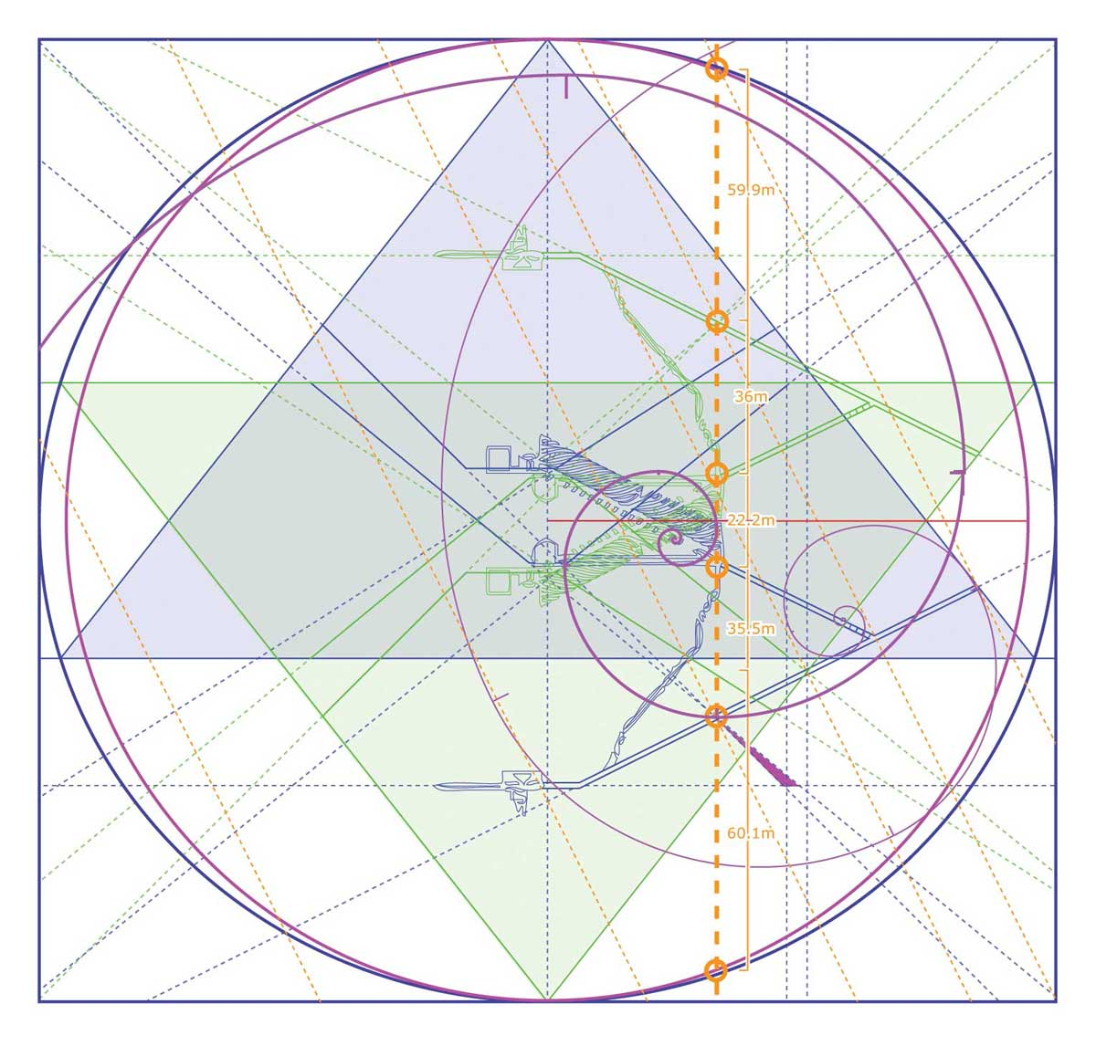
© Ashleigh Watt. 2017 www.tescera.com

Having found point D, I almost failed to realise a more obvious vertical alignment with the top of the well shaft and the start of the Grand Gallery. Being vertical and cutting across the mirror aspects of the diagram, the points of intersection are also mirrored.

At top and bottom, are intersections with the ellipse and the projections perpendicular to the Descending Passage at the entrance, next is point D and its mirror, then the aligned floors of the King’s and Queen’s Chamber. These distances too, rather unsurprisingly, have a Phi relation.

Also of note is that the resulting Fibonacci spiral centre is, like the first one, aligned with the Ascending Chamber.
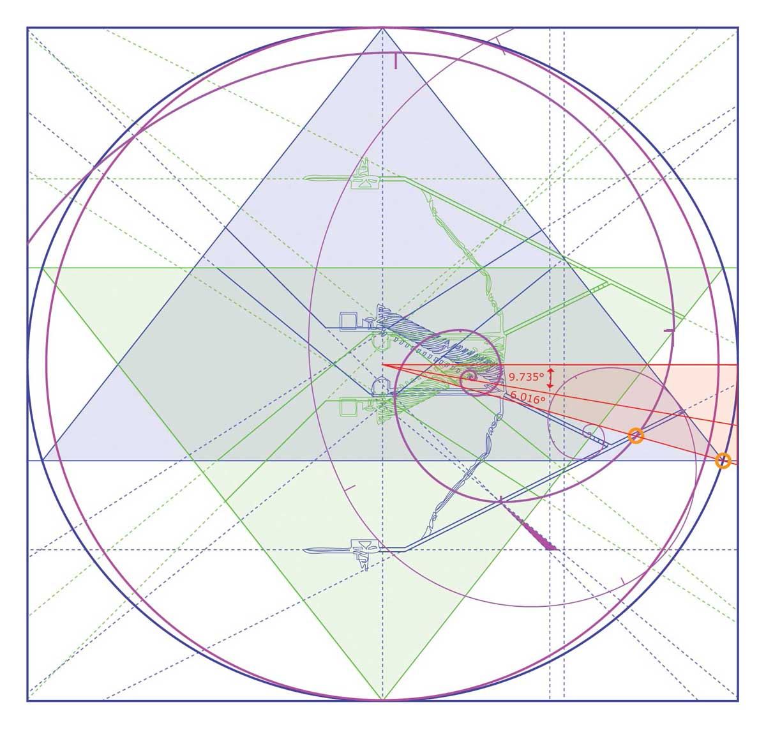
© Ashleigh Watt. 2017 www.tescera.com

One thing I have yet to mention is the angle of the Descending passage, that being 26.5°. That angle suggests a triangle half as tall as wide, what might be considered - ‘two steps forward, one step down.’ If we apply this implicit 1/2 to the distance from the entrance to the junction with the Ascending Passage, we get a very close approximation of the longest distance calculable from the rectangular prism that is the King’s Chamber.
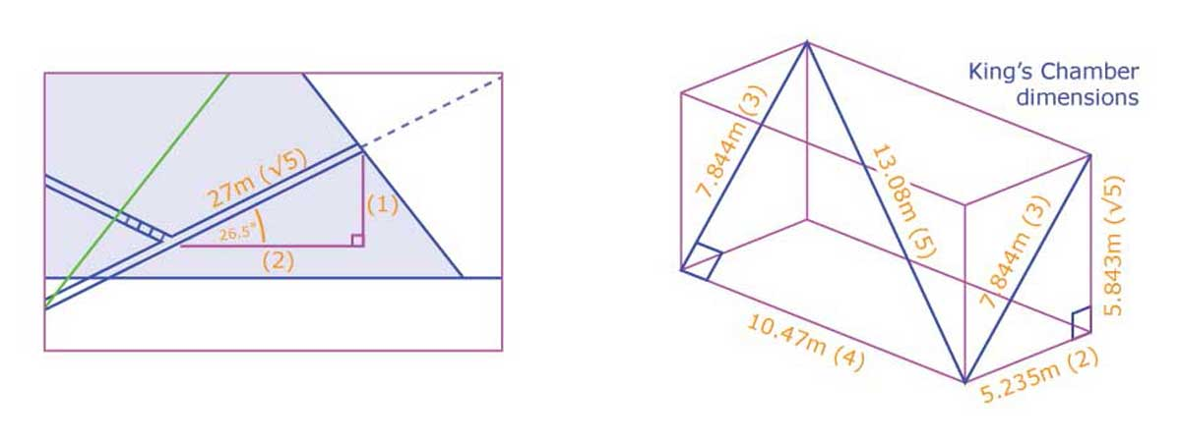
© Ashleigh Watt. 2017 www.tescera.com

If we also apply this 1/2 to the Merkaba angle, of 19.47°, we get 9.735° a line drawn at this angle very nearly intersects the entrance. 9.735° x ɸ = 15.751°, this line neatly intersects the Pyramid corner, and frames the first Fibonacci spiral. Also it intersects the spiral and Descending Passage at a point which divides the initial section of the passage into another Phi relationship.

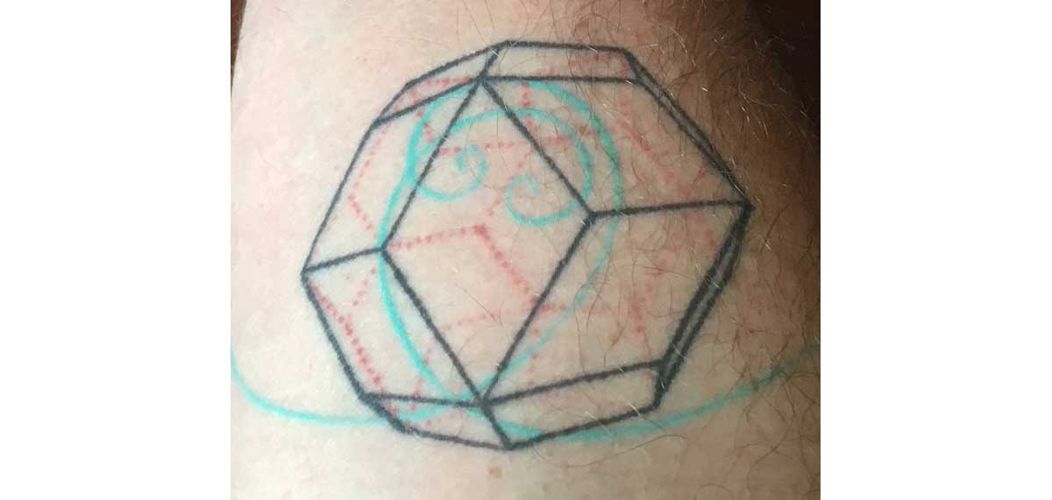
© Ashleigh Watt. 2017 www.tescera.com

On a personal note, this is a tattoo I designed and had done in November of 2015 (my 2nd tattoo) It is an interpretation of my Birthday, the 30th of April. It is a tricontahedron (30 sided shape) made of equal rhombi (4 sided.) As a designer it interested me that each rhombus held to golden mean proportions, but unlike a rectangle 2 Fibonacci spirals would be required to articulate this. Considering the similarities with my diagrams, it seems I must have been trying to tell myself something…
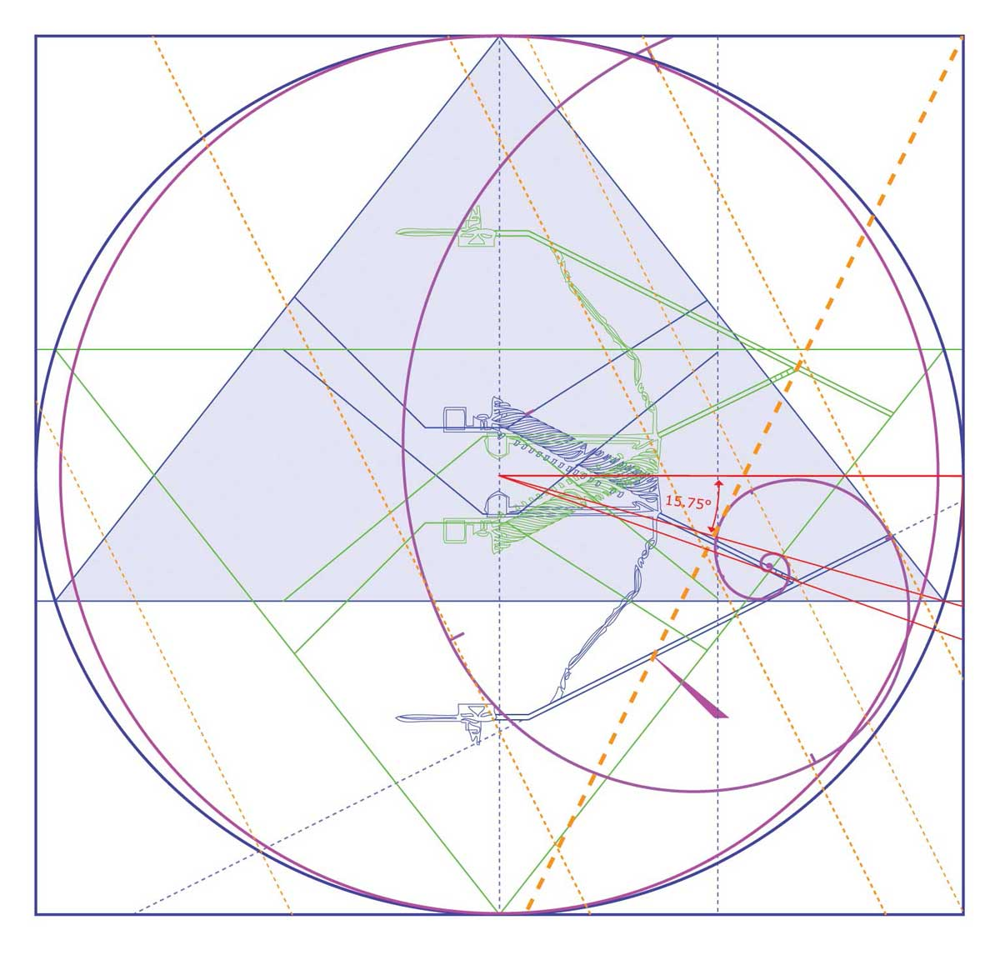
© Ashleigh Watt. 2017 www.tescera.com

This Fibonacci spiral is reinforced by so many alignments that it staggers my mind. In the above diagram I have pared back other details, so that its framing might be less cluttered. I won’t textually articulate all the alignments again, but will point out that the tail, neatly misses the actual Subterranean Chamber on one side, brackets around the King’s and Queen’s Chamber (which with the Well Shaft appears like the seed or nucleus of the Pyramid), and then neatly misses the inverted Subterranean Chamber on its other side.

I’ve probably gone on a little further than necessary in my attempt to justify why I think that there is a secret shaft. But obviously such a theory requires decent evidence. I will now give background information to try to justify why and what I think opening this shaft will cause.

The beginning of my rabbit hole

It seems longer, but 3 months ago, whilst watching an old Graham Hancock lecture on youtube I noted a curious detail, which lead to me writing an article for his site (which at the time of writing this still remains unavailable to the public). That time now seems like when I fell into the ‘rabbit hole.’

Bible Passages

Soon after contacting Graham, I thought Egypt is written about in the Bible, so I forced myself to read Exodus. Beyond the bureaucratic nature of most of it I couldn’t help thinking ‘this Moses guy is a scammer’ Exodus 40:38 “For the cloud of the LORD was upon the tabernacle by day, and fire was on it by night, in the sight of all of the house of Israel, throughtout all their journeys.” This sounds like a damaged or out of control power source, and a guy trying to conceal the truth of a technology by invoking a God.

“Any sufficiently advanced technology is indistinguishable from magic” Arthur C. Clarke

And Exodus 34:29 “And it came to pass, when Moses came down from Mount Sinai with the two tables of testimony in Moses’ hand, when he came down from the mount, that Moses wist not that the skin of his face shone while he talked with him.” - this sounds like radiation exposure, and these are the SECOND set of ten commandments. Could Mt Sinai be The Great Pyramid? And could the tablets be pieces (possibly halves) of the lid of the Coffer in the King’s Chamber? Certainly if Moses broke into the coffer and exposed and possibly damaged a concealed technology, that would explain his glowing visage, and the hacked corner of the coffer. Is this where the concept of a ‘halo’ originates.

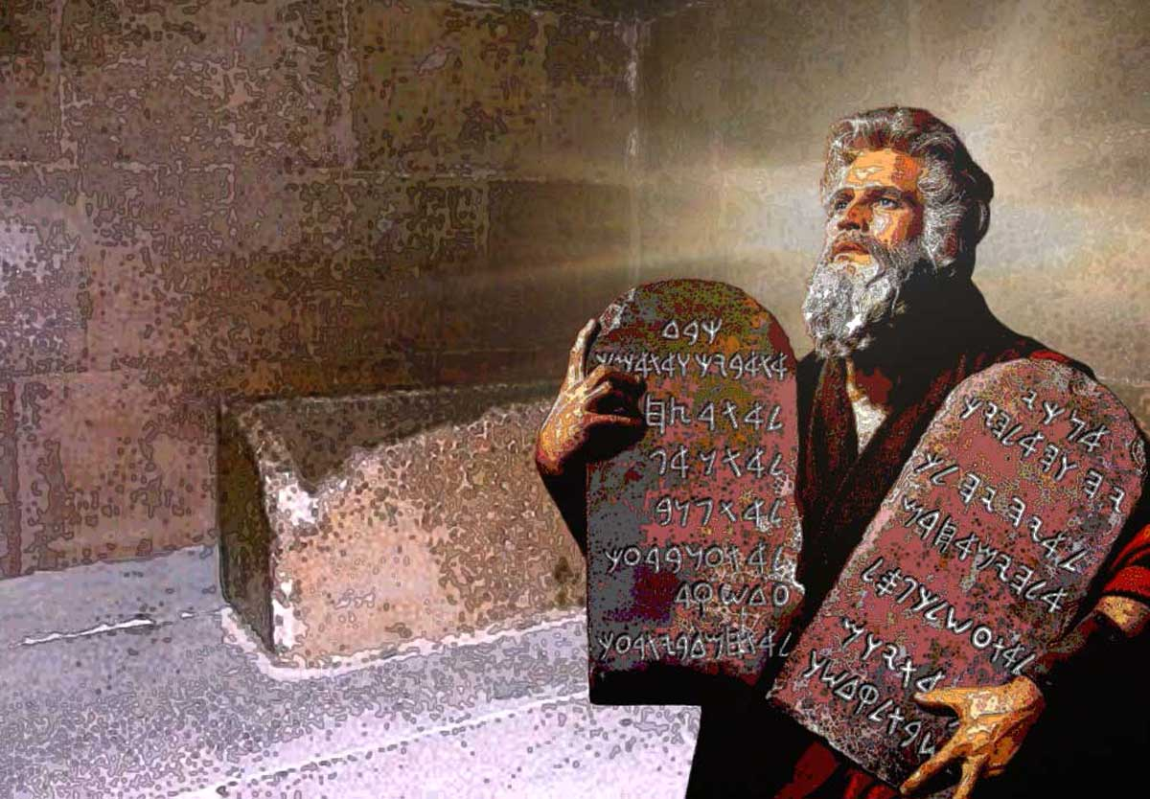
© Ashleigh Watt. 2017 www.tescera.com

So I came to think that Moses stole a technology from Egypt, a technology that possibly only Priests and Princes of Egypt might have opportunity to learn of. And I always thought it intriguing that the ten commandments are always depicted with rounded top corners, does this reflect the finishing of the Coffer lid at either end.

Could the Ark of the Covenant have fitted inside the Coffer? Or could the Ark have been built to contain the contents of the Coffer?
The Coffer internally is 1977 mm long x 677 mm wide x 872 mm tall.
Exodus 37:01 “And Bezaleel made the ark of shittim wood: two cubits and a half was the length of it, and a cubit and a half the breadth of it, and a cubit and a half the height of it:”
Obviously a cubit is a measure that is hard for us to pin down, estimates seem to vary as the distance from the elbow to the tips of the fingers varies from person to person. (445 to 523 mm)
So a conversion window could be [1112 - 1307] mm long x [667 - 784] mm wide x [667 - 784] mm tall. So the length is very roomy, possibly enough to include the supporting staves. The width is snug to too tight. The height is probably roomy enough, but without the lid it is hard to be sure, as a lid might sit into the coffer an unknown distance, therefore reducing available height.

Later I came across the ideas of Ralph Ellis who suggests that Moses is AKA Tuthmose (who if made Pharaoh, would have been Tuthmose V), and his brother Aaron is Akhenaten who reigned as Pharaoh from 1353-1336BC. Akhenaten installed monotheism (much like Moses) in Egypt until it was rejected and he and his retinue were exiled, just like the Israelites. Both groups apparently were allowed a large supply train including much gold and riches, this of course, sounds like one actual group.

Subsequent to the exile Egypt goes into decline, including Pyramid building, the next pharaoh is ousted, and the following - Tutankhamen dies at 18. Could his death have been due to a failure to pass an initiation/ceremony that relied on a concealed technology?

Anti-gravity

Electro-gravitics as Dr Steven Greer would call it is a technology that enables a lessening of gravitational effects, this technology seems to closely aligned with free energy technologies. Regarding the construction of the pyramids, especially the Giza complex, electro-gravitics is the only possible technology or technology possible, that could come close to explaining their construction. Or even a reason for thinking to attempt such a feat.

Without the power, to move staggeringly heavy stone blocks, and probably also without the power to quarry them, it would make sense that Pyramid construction went into sharp decline.

In our era, anyone following in Tesla’s footsteps in developing free energy technologies, attracts attention that ends with these characters disappearing entirely. Only technologies based on death (fossil fuels) and combustion or breaking nuclear bonds are allowed. Solar power, though ‘renewable’ is still a collecting of similar energies. Only wind and hydro technologies produce energies through other means, namely kinetic. Free energy technologies are the technologies of LIFE and consciousness, in this current system only the technologies of DEATH are allowable.

Of the control structures at play in this World, ENERGY is the most important!

The Precession Connection

The Precession of the Equinoxes, is an effect upon the axis of the Earth that is demonstrated by a progression of zodiacal signs rising with the sun on the summer solstice. A cycling through every sign takes 25,920 years. Though each sign might vary in its length, an average for each may be considered a precessional month of 2,160 years.

The number 72 is important for this precession, as it denotes 1° of precession, or 25,920 divided by 360°s. So when we see the occult use of the number 72 it seems to imply knowledge of precession and the broader context that history is embedded in.

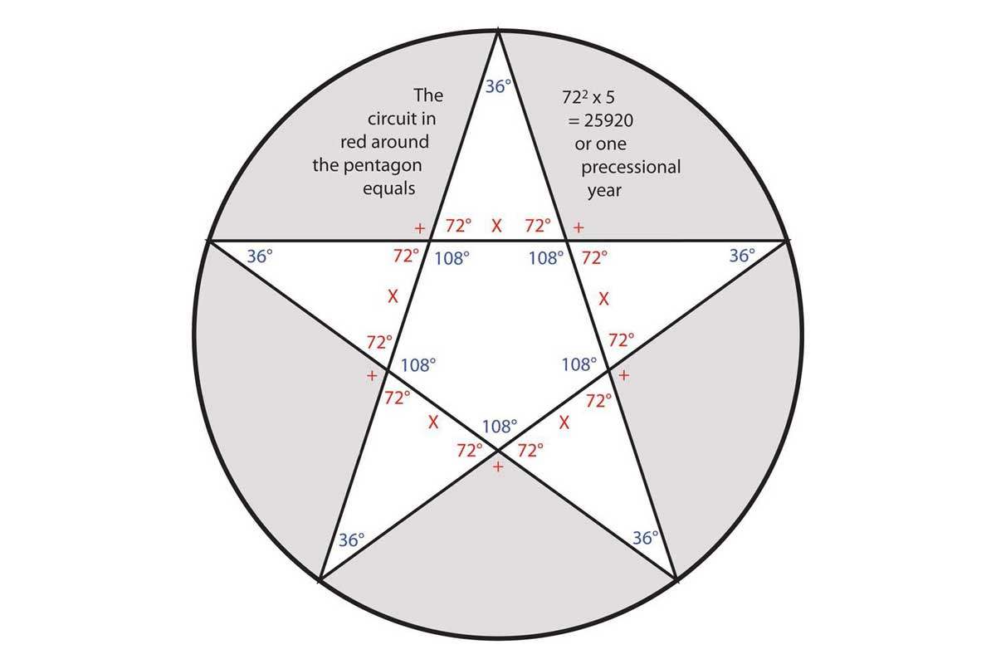
© Ashleigh Watt. 2017 www.tescera.com

Set, with the aid of 72 conspirators killed and dismembered his brother Osiris.

Exodus 2 4:9 “Then went up Moses, and Aaron, Nadab, and Adihu, and seventy of the elders of Israel:” If we consider Moses and Aaron (or Thutmose and Akenaten) as separate and Pharaohic, the remainder of these personages equals 72.

Solomon is credited in the Hebrew Bible as the builder of the first Temple in Jerusalem. The Testament of Solomon describes how Solomon was able to build his temple by commanding 72 demons, by means of a magical ring (the Seal of Solomon.) Solomon’s temple is supposedly the last known resting place of the Ark of the Covenant, that temple was built to reflect the tabernacle’s proportions. As Solomon was known as ‘the Wise’ could it be that he was able to repair the technology at the heart of the Ark, enough to use it to build and cut stone. Could it be that Freemasonry (which at least hopes to trace back to the Temple of Solomon), in essence pertains to masonry freed from hammer and chisel, free of block and tackle? But still locked into measure, shape and control?

So 72-precession and a high technology seem to travel from Giza to the ‘Temple of Jerusalem’ (wherever that actually stood) and there the trail runs cold. Possibly the Arc travelled to Ethiopia with the son of the Queen of Sheba and Solomon, Menelik, but my intuition is that this was a ruse. If Solomon was so wise he probably boxed up a spent fuel cell, or something similarly radioactive and told Menelik to keep it safe for him. The subsequent formation of secret societies, are far more likely to, at least at one time, have part of a true understanding of the Ark. But if I am right the truth of the Ark has faded from relevance.

The Architecture of Deception

For a number of years, prior to thinking of myself as any kind of “conspiracy theorist”, but rather just a political activist, I thought the term was far too heavily loaded. Conspiracies are clearly discernible throughout history, so what’s so crazy about trying to perceive them as they affect society? The answer of course, is nothing, but much effort has been spent in propaganda to ridicule those who might even suggest conspiracies. This leads to a dichotomy between those with the courage of their convictions (a very obvious example being David Icke) and those of more conservative and less intellectually honest means, who modify their thinking and feeling to better fit what is considered sane.

Of course in a plainly insane World, those considered sane are probably insane in a codified and culturally agreed upon fashion. In such a World ‘insanity’ would prove a step in the right direction.

“It is remarkable how similar the pattern of Love is to the pattern of insanity” the Merovingian, Matrix Revolutions

Ridicule seems the first step in undermining ideas that hold truth, part of the process of ridicule involve ‘muddying the waters.’ Crop circles are a good example of this, Much about the phenomenon is purely other worldly, beyond our understanding of technology and staggering from a design perspective (see Zef Damen's geometric reconstructions.) Clearly there are many man-made circles, which are intended to make those of an uncritical mindset happily accept that all crop circles are the product of a couple of guys with boards and rope.

Crabwood

In 2002 a crop circle appeared which contained an interesting message in binary ASCII code

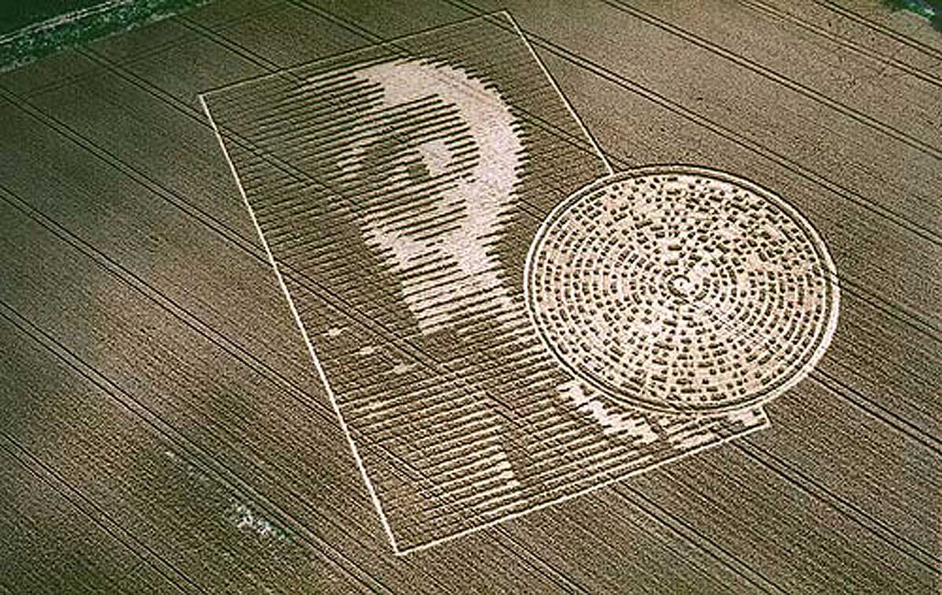
© www.cropcircleconnector.com / M.Williams!
Crabwood Farm House, near Winchester, Hampshire. Reported 15th August. 2002

The message on the disc (from the centre out) translates as “Beware the bearers of FALSE gifts & their BROKEN PROMISES.Much PAIN but still time.EELIE1366E.There is GOOD out there.We oPpose DECEPTION.COnduit CLOSING,” this is normal presented without the mistakes/anomalies as, “Beware the bearers of FALSE gifts & their BROKEN PROMISES.Much PAIN but still time.BELIEVE there is GOOD out there.We oppose DECEPTION.Conduit CLOSING.” As with the variations from perfect accuracy of the Great Pyramid (which were the subject of my article for Graham Hancock’s site), I would tend to think that the anomalies might hold hidden meaning. So when I find a version of high enough resolution I would like to map the anomalies over the disc to see if any patterns are discernible.

Those who I have heard discussing this circle have spoken from a perspective that presumes the “bearers of false gifts” are extraterrestrial visitors that will arrive soon. But the deceivers referred to, could already be here, human or otherwise.

Serendipity

For the longest time I have considered the concept of ‘serendipity’ as a beautifully optimistic concept. Not the very modern version, that which is basically a synonym for coincidence, but that which is articulated by Umberto Eco in his book “Serendipities, Language and Lunacy” in which a succinct definition might be ‘success through folly.’

Recently an intuition lead me to research the etymology of the term and I found that it comes from a story called “The Three Princes of Serendip” translated from an Italian book in 1557, from a Persian tale from 1302. These princes were highly educated, and exhibited stunning deductive capabilities, much like what we would today call Sherlock Holmesian deductive skill. This seems to hide a centuries old attempt to discredit objective critical thinking, and to make such seem like misguided fortune.

Personal Suppression

Recently I underwent what at least felt like the most challenging time of my life, it certainly was from an emotional perspective. Over about 2 years I was the victim of lies, secrecy and gossip. I had started a studying a martial art near my home but almost immediately found that something had gone wrong, but no amount of problem solving or questioning, on my part could expose the truth of the situation. What eventually became clear was that a psychopath had spread lies about me and that part of the nature of the lies was that discussion could not be entered into. Specifically a woman at this dojo had told another (one who I was interested in), that I was a married man. And no amount of questioning could expose the truth of this simple lie. Eventually I was able to guess close to the nature of the disinformation to break the pattern, but not before traversing heart-break and great emotional suppression.

I share this because with the aid of hindsight, this dark night of my soul, had great value. Via this misadventure I have come to better understand the nature of self-delusion that so easily enmeshes most people via their preconceived ideas. And this experience has given me a greater understanding of myself in the context of my community. Not least though, I doubt (without it) that I would be writing this information herein, as it has given the context to see the value of suppression and the fact that the surmounting of such leads to a higher state than was the case prior to suppression.

Secrecy

“How do you keep something secret? You hide it in plain sight!” Dr Steven Greer.

The fact that information is allowed at all but muddied is interesting. Why is any information about UFOs, alternative histories, free energy, etc. allowed to persist? Possibly there is no chance to stop all information that might disrupt the power structures, but intuitively I feel that it service a purpose. If the populace has some chance to know what is really going on but has to run the gauntlet of disinformation, ridicule and obfuscation, then apathy and resignation are a likely result. But also, that truth is available but not discerned, means that subconsciously we don’t feel as divorced from reality as we might. The splinter in our minds is therefore softened!

“The problem is choice” Neo, Matrix Reloaded

Younger Dryas

As background information, the Younger Dryas is an important era to discuss, those familiar with Graham Hancock will be well up to speed. The Younger Dryas was the period from 10,900 BC to 9,700 BC, of climatic cooling. The event that initiated this period is debatable, but evidence suggests immense heat, and therefore a cosmic impact of some kind. The end of this period might too have been the result of another cosmic impact and very likely resulted in what myth recount as the Great Flood or the Deluge.

Artefacts and monuments exist which date to this period or before it, and therefore point to some kind of high civilization that history has forgotten or pretends never have existed. Certainly on the theme of ridicule, Atlantis as a field of study has suffered greatly, even though the idea comes to us from Plato who otherwise is generally not thought to be prone to whimsy.

For more details on this and humanity as a “Species with amnesia” see the Magicians of the Gods by Graham Hancock.

Ark of the Covenant

From a precessional perspective, terms like ‘the arc of history’ take on new meaning. If we map ‘history’ over a precessional zodiac; that is, from Aries through Pisces, and to the beginning of Aquarius, history is but a short arc. Even if we stretch our interpretation; from Leo (and the likely building of the Great Pyramid complex) to Aquarius, the result is still an arc.

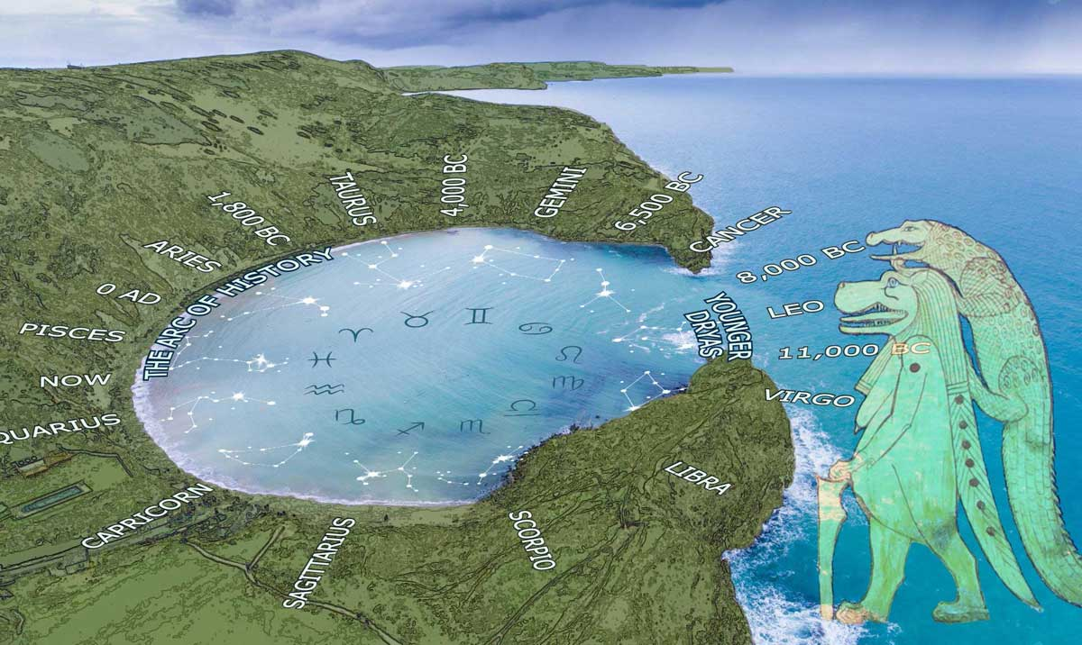
© Ashleigh Watt. 2017 www.tescera.com

‘Covenant’ is what we understand to be an agreement, in terms of the Ark, apparently between God and man. But what other terms seem to resonate with ‘covenant’? Coven, covert, covet, convert and cove. A ‘cove’ is a small circular or ovular inlet from the sea.

The ‘air shafts’ in the King’s Chamber pointed to Orion in the South and Draco in the North in the year 2500 BC. Could the COVEnant (if any) be between aliens from Orion (the stellar nursery) and aliens from Draco the “great Mooring post” (Bauval link) and pole of the eliptic, personified by the Egyptian Gods Taweret (pregnant Hippopotamus) and her consort Sobek. (Crocodile, pictured above.)

It is not lightly that I invoke alien intervention in human history (David Icke would not be so tentative), but when one opens one’s mind to the possibility, rather than dismissing it as purely fanciful, it and a missing free energy device, offer a good explanation of the suffering of the human condition. So if there is a chance to engage a backup device and release humanity from this COVEnant of oppression, and ‘shoot beyond’ into the stars, should we not take it?

I thought to look for a crop circle that might refer to this COVEnant idea and this is what I found

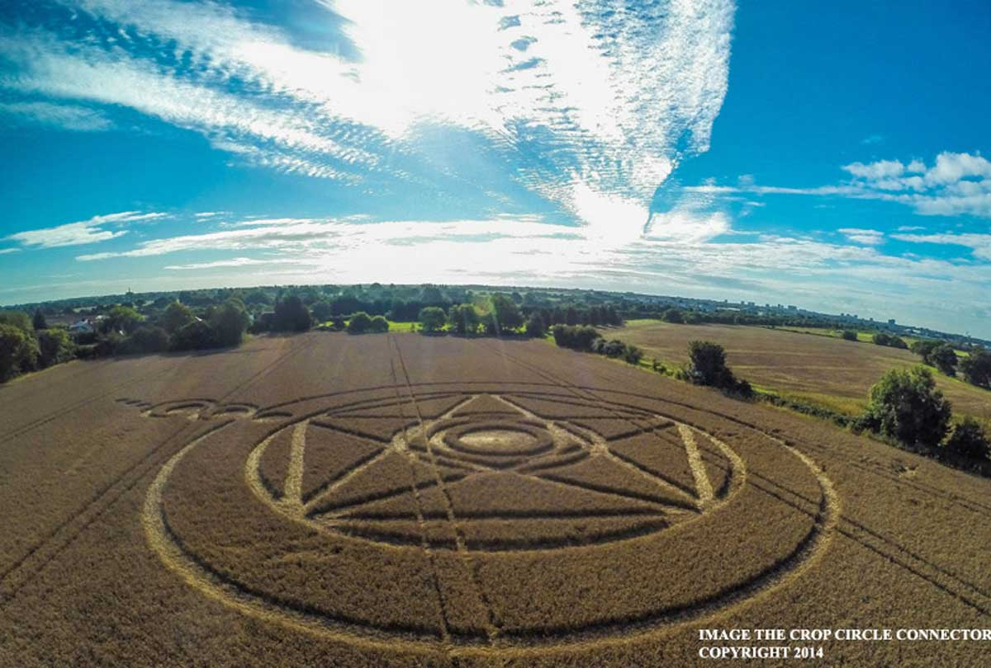
© www.cropcircleconnector.com / M.Williams
Ark Lane (2), nr Stroud Green, Essex, United Kingdom. Reported 31st August 2014

A pentagram suggests a precessional zodiac (as previously explained 72² x 5 = 25,920), though no zodiac signs are even minimally defined. A character enters from outside into our cosmology, it’s almost comedic that this was at ARK lane.

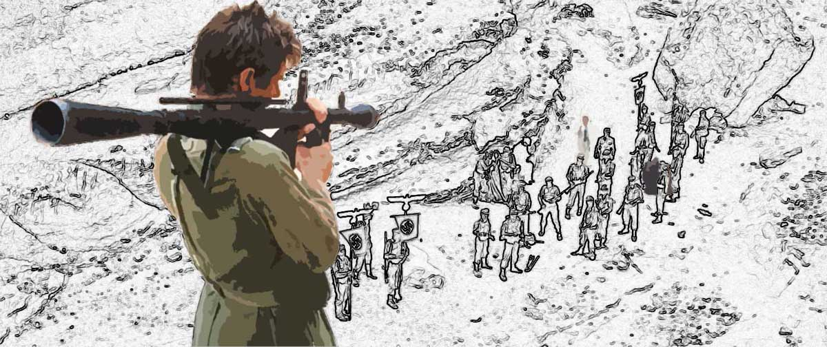
© Ashleigh Watt. 2017 www.tescera.com

From “Raiders of the Lost Ark” moments before this still Belloq (the french Jew working with the Nazis) swallows a fly without seeming to notice, moments after this still he says of the Ark that “THIS IS HISTORY.”

Reptilians

The biblical story of the ‘Garden of Eden’ or Akhenaten’s retelling of the ‘Hymn to the Aten’ points to an idyllic time before history of innocence and ease (probably in line with Terrence McKenna’s ‘Stoned Ape’ theory). This sounds like an age when humanity had it good but didn’t know how good it had it, probably with the aid of a complete coffer in the King’s Chamber. In the Bible it is the snake that leads to humanity’s expulsion, is this story an interpretation of the Northern shaft’s alignment with Draco (astronomically depicted as a snake) in 2500 BC, and the beginning of an influence that has repressed humanity to this day?

Monotheism as pushed by Akhenaten and Moses, has been a crucial vector in the subjugation of humanity. Was it the influence of Draco that had them focus religious power, with ‘Aaron’ as high priest of the new single God religion?

Numbers 21:6 “And the LORD sent fiery serpents among the people, and they bit the people; and much people of Israel died.”

Numbers 21:8-9 “And the LORD said unto Moses, Make thee a fiery serpent, and set it upon a pole: and it shall come to pass, that every one that is bitten, when he looketh upon it, shall live. And Moses made a serpent of brass, and put it upon a pole, and it came to pass, that if a serpent had bitten any man, when he beheld the serpent of brass, he lived.”

This Brazen Serpent or Nehushtan, seems a version of the Uraeus Serpent worn by Pharaohs over their pineal glands. Ancient history has many examples of serpents and their connection to power and law making. The Athenian law maker Draco is of note, he is where we get the word draconian, Draco the constellation also gives us Dracula, dragon etc.

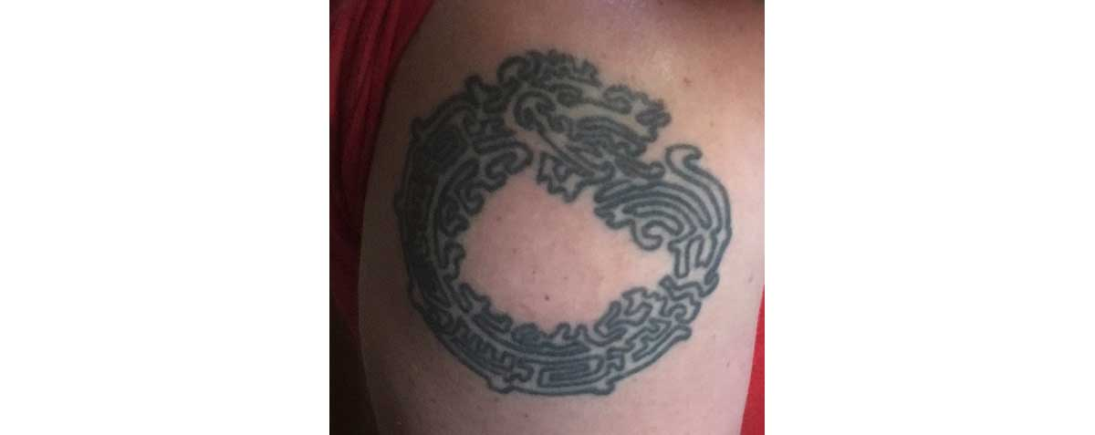
© Ashleigh Watt. 2017 www.tescera.com

My first tattoo (2008) of an altered Mayan Oroborus, formed of a single labyrinthine line akin to Ariadne’s thread. Then I thought it a pervasive symbol suggestive of the cosmos, now it seems the precessional trap humanity is lost in.

Also I have to wonder at the word ‘serpent’, does the pent have a connection to 5 and pentagram and therefore the 25,920 year zodiac?

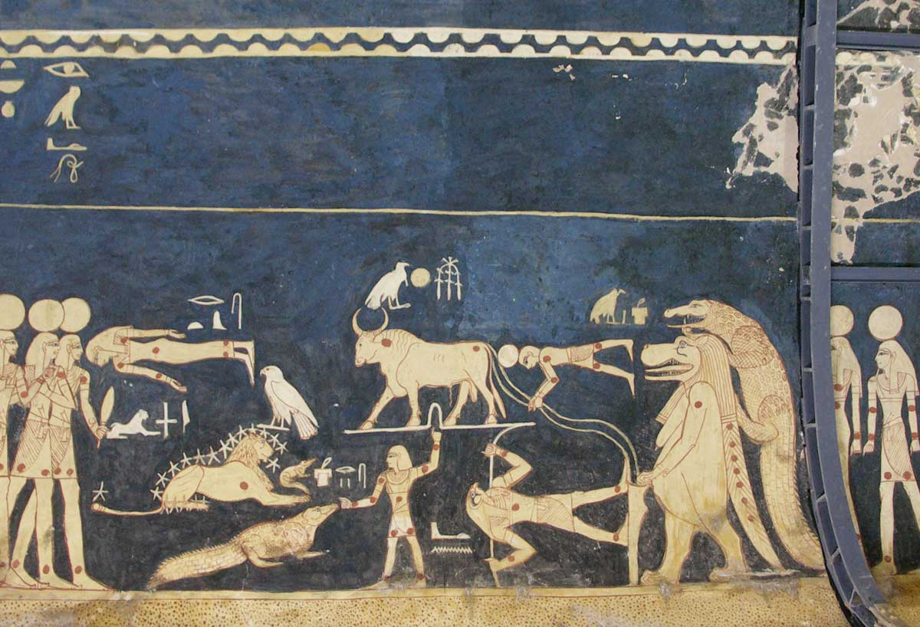
© Bill Petty www.museum-tours.com
From Seti I tomb, Taweret and Sobek hold the celestial mooring post, which the constellations are tethered to.

Repression, law and punishment, division and control, war and false flag incitement, financial slavery, and inequality all aide the draconian intent. Humanity is held back, our energy kept from expansion, love, acceptance, empathy, creativity and critical thinking, are tactics to thwart this intent, and to evolve our consciousness into higher dimensions.

The Middle-East

For over a century the Middle-East has been a war zone, territorially disputed and generally contentious. The military-industrial complex has its focus on this region, generally fossil fuels are seen as the reason for conflict and regime change, or possibly the pursuit of ‘Greater Israel.’ But is this reason for subterfuge, a subterfuge in itself? Curiously the Zionist agenda imagines an expanded territory that in its western reach would only just encapsulate Giza, and therefore possibly forestall the connection of the backup device. Otherwise it seems war and demolition in this region makes archaeology and a greater understanding of our ancient past ever more challenging. Is it really oil that they are after? In a time when many are interested in our ancient past is it any wonder, that war and unrest make research into this past ever more challenging?

Noah’s Ark

I don’t mean to say much about this, but want to make a couple of points. Obviously this is the same term again (ark), and again its true meaning is a time reference. Otherwise, something that I have heard mentioned but not heard anyone closely consider, is the fact that a number of mummified animals in subterranean chambers exist around the Giza complex.
If a culture wanted to safeguard life on this planet, and expected climatic effects like the melting of glaciers or a cosmic impact - rather than a leaky boat, wouldn’t mummification offer a longer term (and therefore more realistic) solution. With a store of genetic information the flora and fauna of this planet could be cloned back into existence, after a great flood. The story of which can be found in nearly every culture’s history.

Might the mummification of Egyptian Kings be a corruption of this arking of genetic material intended for cloning, just as the tombs seem a homage to, or imitation of the Giza Pyramids.

Eschatology

Armageddon, Ragnarok, whatever word is used for the end of the World, it is yet more deception. The prophesied end is that of the control vector, and/or that of the COVEnant.

The Blue Sarcophagus

In what is known as the ‘Tomb of Osiris’ (video of Erich Von Daniken discussing it) is a mysterious Blue Granite Sarcophagus. It and most of the lowest chamber are submerged in water, and curiously this water is crystal clear and fizzes when anything drops into it. Even more curious is the fact that through water refraction might be discerned 2 bearers or joists holding the sarcophagus off the floor. I may be fairly fresh to Egyptology, but I have never seen this before.

The first moment I saw footage of this I thought of the King’s Chamber Coffer. Information about the blue Sarcophagus is terribly limited, access to this chamber is apparently external to the Great Pyramid, but the actually Sarcophagus is under the Pyramid. Intuitively I though the water must act as some sort of insulator and subsequently heard Richard Hoagland discussing just that, apparently “the shielding effect of water, because water screens torsion, because of the hydrogen, oxygen bonding” (https://youtu.be/uMjEohQUHC4 43 minute mark.)

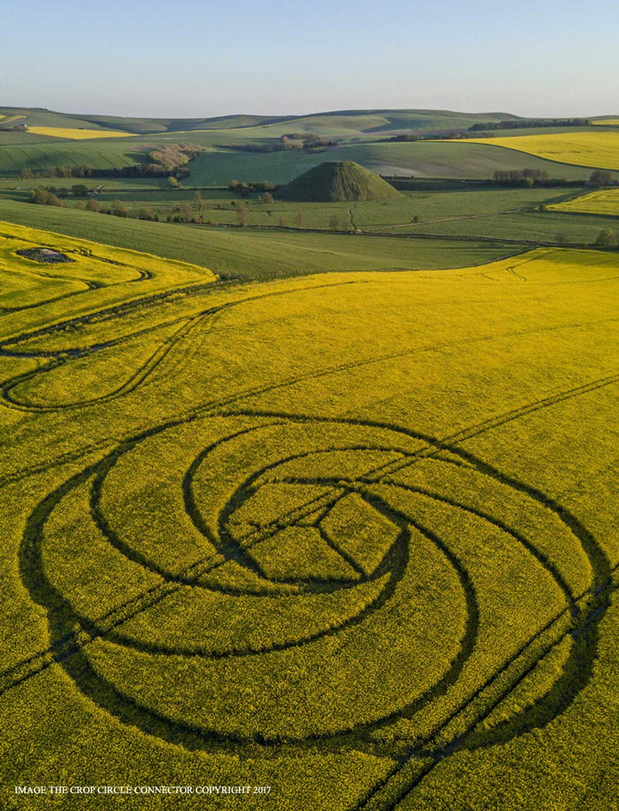
© www.cropcircleconnector.com / M.Williams
Waden Hill, Nr Avebury, Wiltshire. Reported 22nd April. 2017

The above circle has a basic cube (which especially at this orientation implies the Merkaba) surrounded by a torsion field (cycling donut shape, similar in shape to the Van Allen belts of the Earth) implicit in free energy.

I won’t pretend to understand torsion fields, but they appear to have a similar nature to the toroid, which is the common element of free energy devices.

The Sarcophagus is apparently impregnable, so of course many want to open it. Unlike The Coffer, or Pandora’s box, this backup Sarcophagus should remain closed, thankfully this seems not a matter of choice.

When the water is drained, the Sarcophagus will be exposed on its bearers. I am very curious to know what material they are composed of. What then happens to the bearers, I don’t know. Maybe they will need to be manually removed, but I expect the designers have planned for this part. When dry, they will probably be pulverized by sheer weight. Once connected to the floor, I expect a cleansing and possibly powering of the energy centres of the Earth.

Therefore the power of the controllers will be broken and true humanity may evolve, freed from shackles.

“Why are the Pyramids made of limestone? Because limestone turns out to be an incredibly important torsion active amplifying material” Richard Hoagland.

Aquarius

The song from the musical Hair suggested that it is the “dawning of the age of Aquarius”, but the exact date of the cusp or transition from Pisces to Aquarius is debatable. Could the age begin when these waters are allowed to flow? If I am right about a secret panel that conceals a shaft that continues down at an angle, then how could water flow up-hill and out than exposed shaft-hole? Well if you’re as crazy smart as the Pyramid builders you probably have a handle on siphonic effects. This is partly why I think the panel is in the ceiling, the secret shaft probably passes the height of the Descending Passage by some measure, and then turns back down to the ceiling. Therefore if water is in that downward section, allowing it to flow out will act like a siphon drawing the water up and out. The other reason I think the panel is in the ceiling is because of the connection to the queen’s chamber. It seems to me, that the nature of the previously concealed panels are not to be dismissed lightly. Their height and size is likely the same for the panel at point D, IE at a height of 120 cm (which is the height of the Descending Passage) and 20 cm wide and tall. That is mostly intuition, but also approximately 20 x 20 cm seems a likely sized output for the siphoning of a subterranean lake.

If water is intended to flow into the lower part of the Descending passage, and to fill the Subterranean Chamber, and most of the Well, could this explain why the Subterranean Chamber is rough-hewn? IE Is it unfinished because it is intended to be submerged? Similarly, is the intent of the Grotto near the top of the Well to simply fill with water?

I had of course imagined putting on my Indianna Jones hat and heading off to Giza, and breaking this panel myself, but I am just one man and as such could fail but if I can spread this information and it resonates with enough people then the people ‘shall over-come.’

Movies and Books as mythology

I’ve always been interested in Mythologies, but now I see resonances of the various above ideas in many of the books and movies that have resonated with me. So I can’t help discuss some of the more relevant examples.

Arthur C. Clarke - I already used an image from 2001: a Space Odyssey - the monolith is a teaching tool which is linked to another larger monolith that evolves Dave. The Pyramid - teaching tool and its Coffer link to a larger Sarcophagus which may cleanse humanity and Earth’s energies to a similar evolution. A Childhood End, recently produced as a 3 part TV movie, (apparently Kubrick wanted to make this too, back in the day but Lucas owned the rights) is a wonderful story about alien visitation. These aliens look like demons, as part of some future sensing of the end of humanity and the evolution of its children. These aliens can’t evolve to become part of cosmic consciousness but act as wet-nurses to the process. Demonic in another way the influences of Draco, through forms of repression seems necessary for the immanent consciousness evolution.

The Dark Crystal - supposedly the first fully puppeteered film, I loved this as a child. In an ancient past the Dark Crystal was fractured, and beings were split into a good and an evil species. The evil Skeksis drain the life-essences of various creatures, like our vampiric Draconians. Ged, a small near extinct creature journeys to reunite the shard (with the crystal) during the great conjunction, thereby the good and evil species are united into a more evolved life -form.

Dune and the sequels- by Frank Herbert. There are a few interesting ideas in Dune; higher states of consciousness, “traveling without moving” between star systems, bringing water to a dry world, monstrous worms that consume anything that vibrates, human - worm hybridization, and the ‘Golden Path’ which Leto II as hybrid worm instigates to repress humanity so that at his demise humanity reaches out ever deeper into the stars. There is something else that is possibly just supposition, but I just can’t shake; the desert planet is Arakis, with the addition of El (the semetic word for God, and a typical vowel dropping) we get Alrakis, which is a traditional name for the star system in Draco, Mu Draconis. And Mu is the ancient Greek letter that became our ‘M’, (as did the Egyptian hieroglyph for water) but also the Greek Mu denotes 40. And 40 is an obviously occult number that turns up in the originally Greek Bible on many occasions. So does Jesus wondering in the wilderness for 40 days and nights, or the Israelites in the desert for 40 years, refer to Mu Draconis, and its interstellar influence?

Alien COVEnant – The latest Alien movie, didn’t resonant with me like these others, but is worth mentioning. Clearly the title is interesting, and the whole Alien concept is of a parasitic life form born of human death. The logo of this mission is a version of the Egyptian Winged Sun.

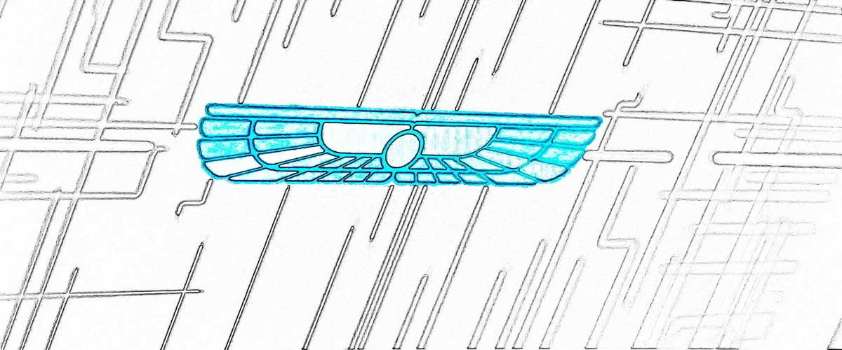
© Ashleigh Watt. 2017 www.tescera.com

“Serve in heaven or reign in hell, which is it to be?” David the Android

Conclusion

As implied earlier the intent of sharing this information is so that more than my single person might have a chance to test my theory and intuition. Egotistically, I could presume to be the one that breaks this panel and ushers the Age of Aquarius but what is important is that it is ushered in at all, not by who. In any case, constraints on me mean it is unlikely that I could find myself in Giza any time soon, and I think time is of the essence. Armageddon seems immanent, but Armageddon is not something humanity should fear but rather relish. “It’s the end of the World as we know it” (as REM professed) as we should feel fine!

The Great Pyramid is a teaching tool beyond the scope of normal human understanding, it has protected and sheltered humanity, it has exposed the innocent to the dangers of innocence. Thereby it has allowed humanity to be held down, and like a coiled spring or submerged ball it is only a matter of time and focused intent before humanity uncoils and shoots beyond our perceived limitations. The time has come, the stage is set, and the actors could be anybody!

At about 69 metres (227 feet) down the Descending Passage from the entrance of the Great Pyramid of Giza, one with the aid of dowsing rods is likely to find a panel in the ceiling that wants to be broken. When broken water is likely to flow and drain the waters surrounding and insulating the backup Blue Sarcophagus (held in a lower chamber under the Pyramid), enabling an energetic and consciousness shift of this planet and its people.
© Ashleigh Watt. 2017 www.tescera.com

References
Coffer dimensions
http://www.rickrichards.com/egypt/Egypt7_coffer.html

Diagrams based on Pyramid dimensions from
http://www.theglobaleducationproject.org/egypt/studyguide/gpmath.php
https://greatpyramidmath.weebly.com/contents.html
https://www.cheops-pyramide.ch/khufu-pyramid/stonecourses-pyramid.html
http://www.catchpenny.org/shafts.html

Influential Thinkers / Intended Recipients

Graham Hancock - https://grahamhancock.com/
Robert Bauval - http://www.robertbauval.co.uk/
John Anthony West - http://www.jawest.net/
Jo Rogan - http://joerogan.net/
David Icke - https://www.davidicke.com/
Richard Hoagland - http://www.enterprisemission.com/
Erich Von Daniken - http://www.daniken.com/en/
Ralph Ellis - http://edfu-books.uk/
Dr Steven Greer - http://www.disclosureproject.org/
Nassim Haramein - https://resonance.is/
Jim Marrs - http://jimmarrs.com/
Michael Tellinger - http://michaeltellinger.com/

Images Used with Kind Permissions

M.Williams - www.cropcircleconnector.com
Bill Petty - www.museum-tours.com
Colin Andrews - http://www.ColinAndrews.net/

